The Internet practice website- web application
User login test cases

Module Name: The Internet practice website-user login test cases
Test case ID: TC006
Platform: Web application(Responsive)
Login Method: username + password

Scenario ID: 1
Scenario: login with valid credentials
Test steps:
- Enter valid username: tomsmith
- Enter valid password: SuperSecretPassword!
- Click on login

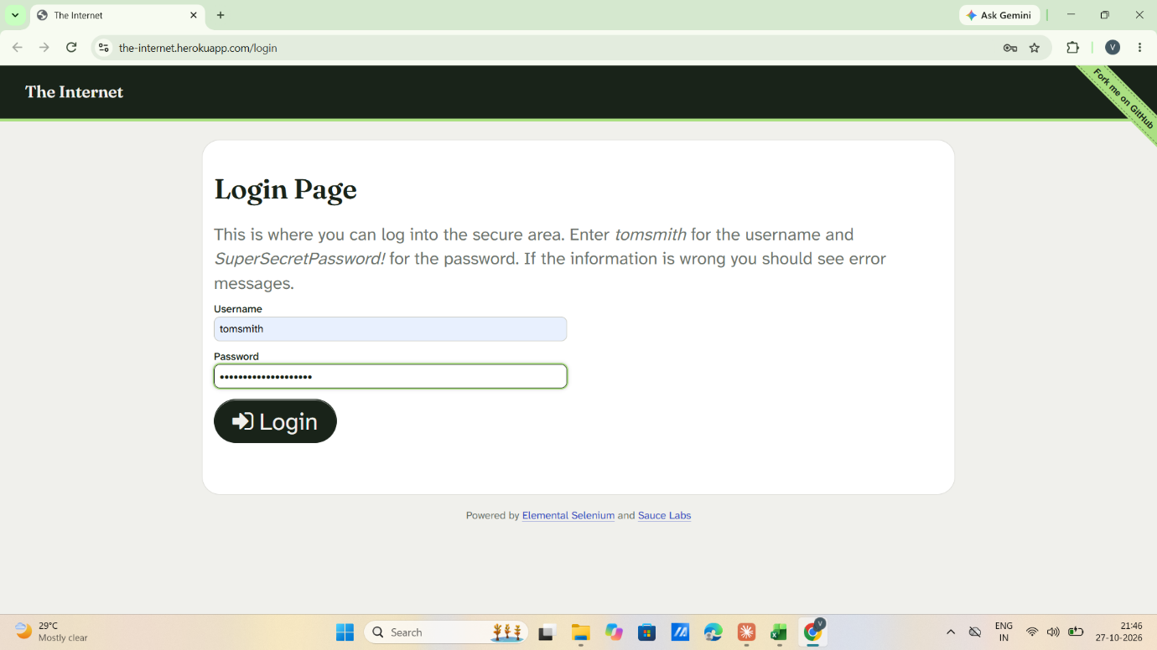

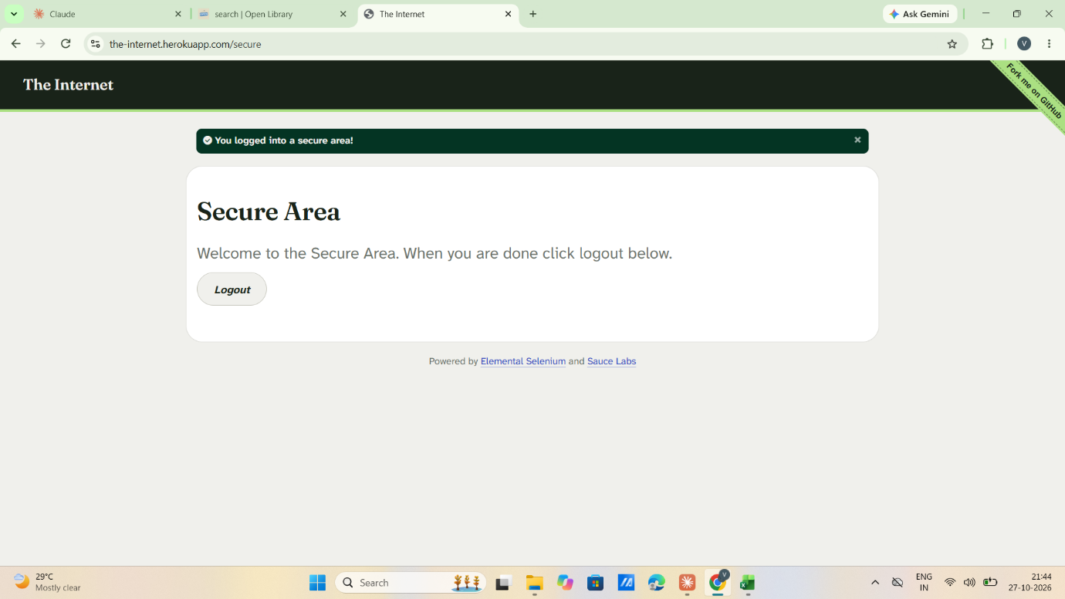

Scenario ID: 2
Scenario: login with invalid password
Test steps:
- Enter valid username: tomsmith
- Enter invalid password: wrongpass
- Click on login

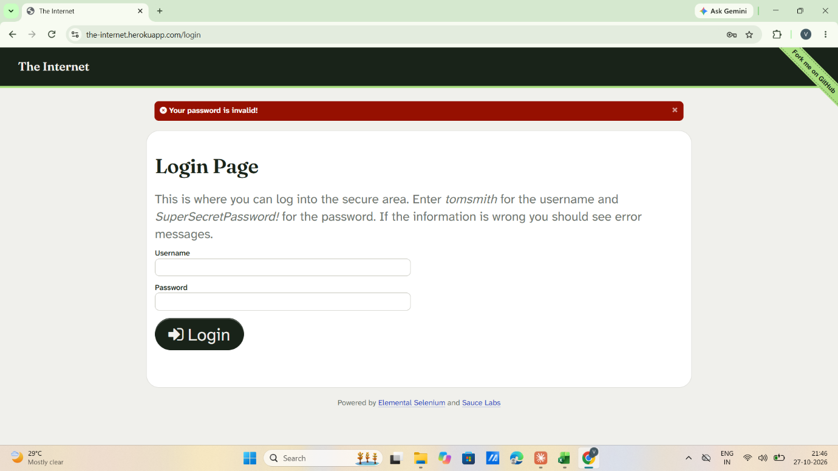

Scenario ID: 3
Scenario: login with invalid username
Test steps:
- Enter invalid username: wronguser
- Enter valid password: SuperSecretPassword!
- Click on login

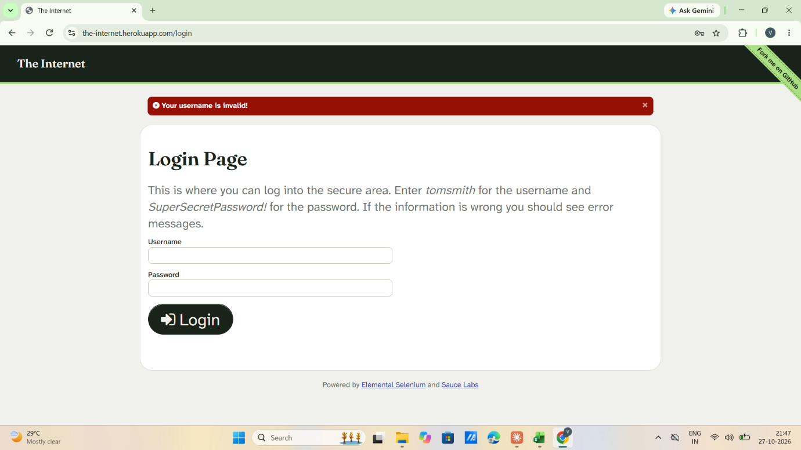

Scenario ID: 4
Scenario: login with blank fields
Test steps:
- Enter username: -
- Enter password: -
- Click on login

Scenario ID: 5
Scenario: login with invalid username and invalid password
Test steps:
- Enter invalid username: wronguser
- Enter invalid password: wrongpass
- Click on login

Scenario ID: 6
Scenario: login with different letter case in username
Test steps:
- Enter username: TOMSMITH
- Enter valid password: SuperSecretPassword!
- Click on login

Scenario ID: 7
Scenario: Cross Browser test
Test steps:
- Enter valid username: tomsmith
- Enter valid password: SuperSecretPassword!
- Click on login
- Repeat on Chrome, Edge and Firefox

Scenario ID: 8
Scenario: logout functionality
Test steps:
- Enter valid username: tomsmith
- Enter valid password: SuperSecretPassword!
- Click on login
- Click on Logout

